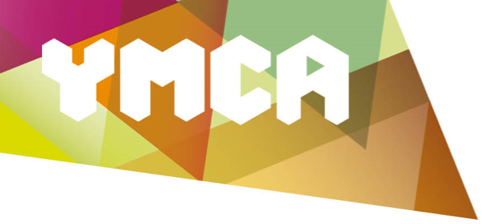

Donation Form

Title
First Name(s)

Family Name

Postal address

Email address

☐ Please send me email updates about the work of YMCA Essex.

One-off donation amount: £

☐ If you would like to be contacted about setting up a regular gift to YMCA Essex, please tick this box.

If I have ticked the Gift Aid box below, I confirm that I am a UK tax payer. I want YMCA Essex to reclaim tax on the donation detailed here, given on the date shown. I understand that if I pay less Income Tax and/or Capital Gains Tax in the current tax year than the amount of Gift Aid claimed on all my donations it is my responsibility to pay any difference. I understand that YMCA Essex will reclaim 25p of tax on every £1 that I have given.
☐

Signed: |  | Dated:

Once completed, please send your donation with this form to:

YMCA Essex
Victoria Road
Chelmsford
Essex
CM1 1NZ

Thank you. Your support is very much appreciated.
Registered charity: 1054070

