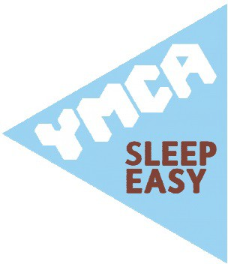
Sleep Easy for YMCA Essex Friday 13 March 2020

1054070

