Emergency
Childcare form
Ofsted registration number: EY 203765

Child’s Surname
Child’s First Name
Child’s Date of Birth
Address

Please tick the days you require your placement for:
Monday AM | Monday PM | Monday Full Day
Tuesday AM | Tuesday PM | Tuesday Full Day
Wednesday AM | Wednesday PM | Wednesday Full Day
Thursday AM | Thursday PM | Thursday Full Day
Friday AM | Friday PM | Friday Full Day

When would you like your placement to start?

Arrival Time:
Collection Time:

Does your child have any  medical requirements or  problems we should be aware of? | Yes - please explain. | No
Does your child require regular  medication administered whilst at Nursery? | Yes - please explain. | No
Does your child suffer from any  allergies? If so, how is this allergy managed? | Yes - please explain. | No
Does your child have any specific  dietary requirements? | Yes - please explain. | No
Does your child require a sleep whilst at the Nursery? | Yes - please explain. | No
Has your child or member of your family self isolated due to corona virus?
1. | Date:
2. | Date:
3. | Date:
Which infectious illnesses has your child had?
1. | Date:
2. | Date:
3. | Date:

 | Doctor | Health Visitor
Name
Address

Telephone
Number

Is there any other relevant information you feel we should know including any additional needs your child may have.

Failure to disclose any additional information that is deemed important, could
result in us no longer being able to care for your child.

To help us maintain the care of your child, we have devised a form seeking
permission to use the following items. If you have previously completed this form, can I still ask that you complete it again, as it will provide us with up to date
information.

Thank you
 | YES | NO

Bandages

Micropore Tape

Plasters

Gauze

Calpol

Baby Wipes

Cotton Wool

Sudocream

Piriton

Nurofen

Vaseline

Comments:

Parent’s Name:
Signature:
Date:

Who has parental responsibility for this child?
Who does the child live with?
Mother’s Name
Mother’s address
Mother’s place of work
Mother’s contact details | Home:  Work:  Mobile:
Email address (for E-invoices)

Father’s Name
Father’s address
Father’s place of work
Father’s contact details | Home:  Work:  Mobile:
Email address (for E-invoices)

Does your child have any siblings?
Sibling’s Name | Sibling’s Date of Birth

Ethnicity Codes
This will be shared if requested with the Local Authority.
01 White British | 11 Asian or Asian British - Other Indian
02 White Irish | 12 Asian or Asian British - Pakistani
03 Other White | 13 Black or Black British
04 Mixed - Other Mixed | 14 Black or Black British - Africian
05 Mixed - White & Asian | 15 Black or Black British - Caribbean
06 Mixed - White & Black African | 16 Black or Black British - Other Black
07 Mixed - White & Black Caribbean | 17 Unknown
08 Asian or Asian British | 18 Traveller
09 Asian or Asian British - Bangladeshi | 19 Chinese
10 Asian or Asian British - Indian | 20 Any

 | Ethnicity Code | Main Language Spoken
Mother
Father
Child 1
Sibling 1
Sibling 2
Sibling 3
Is there any other relevant information you feel we should know?

Data Protection

YMCA Essex will collect your data as per GDPR requirements.
We will store them securely and they will only will be accessed by authorised staff.
Please see our Data Privacy Notice & Retention Policy for further details.
We will safely and securely destroy your data as per our Data Retention Policy.

**************************************************************************

SECURITY

Should somebody else need to collect your child, we will require a
password to release your child.

All staff are trained to ask for this password if they do not recognise the person collecting your child.

Thank You

****************************************************************

Child’s Name:

Password:

Parent’s Signature:

Date:

Sticky Paws is the operating name of YMCA Chelmsford
Thank you for taking the time to complete this registration form.
Don’t forget to download the full policies and
procedures from our website.
********************************************

Any questions?

Call us on 01245 355677
Email us at enquiries@ymcaessex.org.uk
Website ymcaessex.org.uk

*********************************************
Thank you
Sticky Paws Team

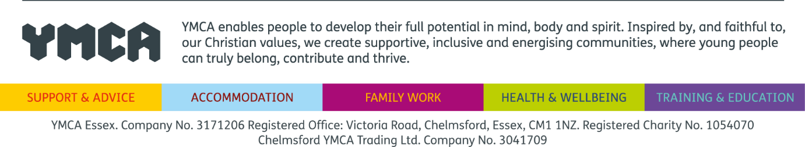
Ofsted registration number: EY 203765

