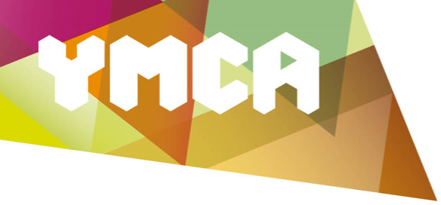

Donation Form

Title:
First Name(s):

Family Name:

Postal address:

Email address:

If you have a particular cause that you would like your donation to go to, please let us know in the box below:

One-off donation amount: £

☐ If you would like to be contacted about setting up a regular gift, please tick this box.
☐ Please send me email updates about the work of YMCA Essex.

If I have ticked the Gift Aid box below, I confirm that I am a UK tax payer. I want YMCA Essex to reclaim tax on the donation detailed here, given on the date shown. I understand that if I pay less Income Tax and/or Capital Gains Tax in the current tax year than the amount of Gift Aid claimed on all my donations it is my responsibility to pay any difference. I understand that YMCA Essex will reclaim 25p of tax on every £1 that I have given.

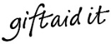
☐

Signed: |  | Dated:

Once completed, please send your donation with this form to:

YMCA Essex
Victoria Road
Chelmsford
CM1 1NZ

Thank you. Your support is very much appreciated. Registered charity: 1054070

