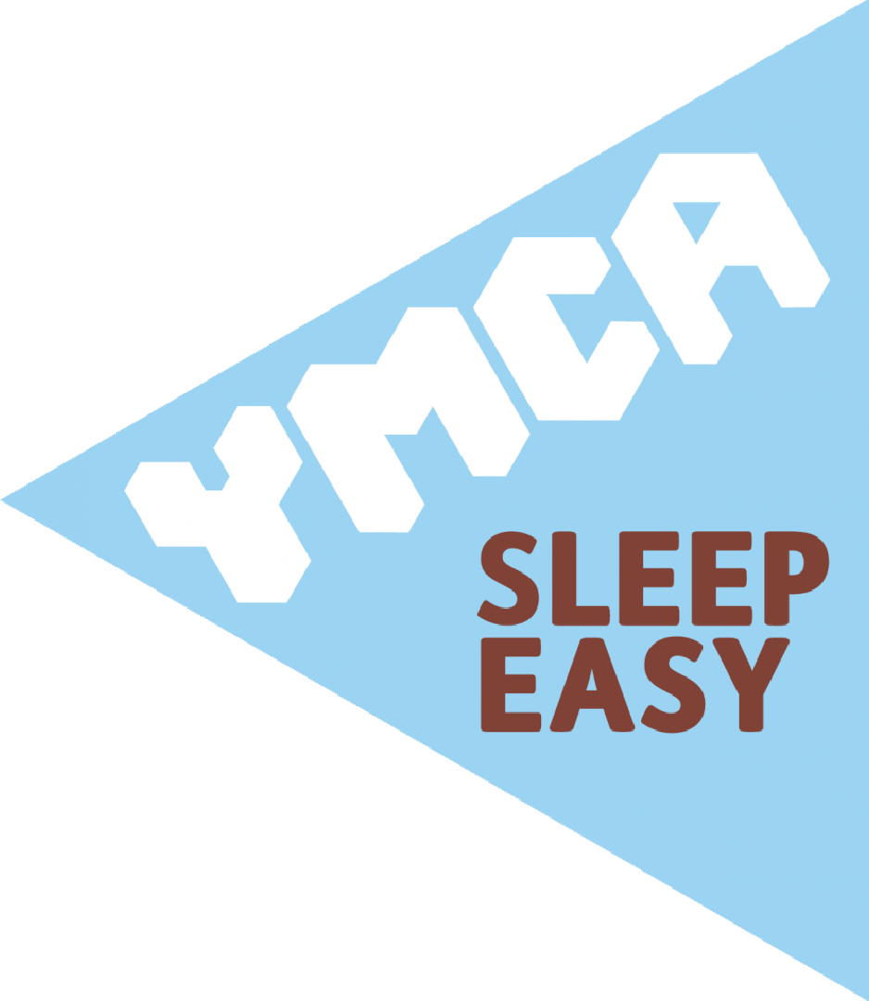
Sleep rough so others don’t have to!

YMCA Essex Sleep Easy 2020 - FAQs

When? 7pm on Friday 13 March. The event will conclude at 7am on Saturday 14 March.
Where? YMCA Colchester Activity Centre
Is there an entry fee?
Yes, a £5 entry fee is payable per person. This is payable via Eventbrite, Bank transfer or cash on the night. If you wish to pay by bank transfer, these are the details you need:
Bank: Barclays Bank Sort code: 201995 Account number: 90280828
Who can enter?
Everyone aged 11 or over can enter, but under 18’s must have a parent or guardian accompanying them (not an older sibling or friend).
How do I register?
You can register online or paper-based. The easiest way to sign up is through Eventbrite and you can do so here. We cannot accept any last-minute sign ups on the night. Registration on Eventbrite and on paper will close 1 week before the event starts, on Friday 6 March.

Do I need Sponsors?
Sleep Easy is primarily a fundraising event, and we’re asking everyone who takes part to try and raise a minimum of £20. Money donated will go towards helping YMCA Essex’s work with vulnerable young people.
You can send a JustGiving link to family and friends for them to give donations that way or use a sponsorship form, which you can download from our Sleep Easy webpage (or pick one up from our Chelmsford office).
We encourage you to use Email, Twitter and your Facebook page to spread the word.

Do I have to sleep out all night?
To help provide insight into what it’s like for homeless young people who have to spend a night (if not longer) on the street we would encourage you to sleep out as long as possible. However, we appreciate you sleeping out for as long as you can manage. The event will end with breakfast for those who manage to last through to the end at 7am.
Please consider how you will get home safely in the morning, or if you decide to leave in the night. It would be advisable to put a plan in place with a friend or relative who could collect you if necessary. Bear in mind that public transport might not be running and you may be cold and tired. You will also need to dispose of your own cardboard box.

How should I create a Shelter?

You will need to bring enough cardboard to build your shelter with (you may want to plan or build your shelter in advance). Also remember to bring strong tape and bin bags or plastic sheets to waterproof it.

Bring enough cardboard and blankets to sleep on, so you aren’t in contact directly with the floor as it can get quite cold.

We will share information on our website and social media regarding shelter building on the run up to the event, so do keep a look out.

Please be aware that you will be responsible for removing and disposing of your shelter at the end of the event.

What else do I need to bring on the night?

You will need to bring warm clothes, a sleeping bag, gloves and a scarf. We don’t know what the weather will be like but it could be cold and wet so please be prepared for all weather conditions. We will not be able to supply you with any items such as a sleeping bag on the night.

As we are trying to highlight what it’s like for rough sleepers, we ask you not to bring luxuries such as tents, camp beds etc. Camping chairs will be permitted to those with special health requirements but please bring your own as these will not be provided. We recommend that you do not bring valuables as we are unable to take responsibility for any possessions that are lost or damaged.

Where will I be sleeping rough?

The event will be taking place in at a secure site, and we will have access to the on-site toilet facilities.

Is it safe to sleep there all night?
Yes. There will be YMCA staff present and awake all night to make sure all participants feel safe and supported throughout the event.

There are alternative arrangements in place to take the event indoors if weather conditions become too extreme. This will only happen in exceptional circumstances.

What happens if I feel unwell in the night?
Sleep Easy is not an ‘easy’ experience and you should consider your health before taking part in this event. If you feel unwell in the night you should speak to a member of the YMCA staff team as soon as possible. There will be trained first aiders present to deal with any first aid issues.

Please disclose any existing medical conditions you have and any medication you are taking on your registration form, so we have sufficient information available if you need some help.
Before coming to the event, you should plan in case you do need to leave during the night considering that public transport may not be running, and you will be very tired. YMCA Essex cannot take responsibility for getting you home during or after the event.

Will there be photographers there? What if I don’t want my photo taken?
Yes, we hope to take plenty of photographs on the night. If you do not want to be included in these pictures, please indicate this on your registration form and highlight it to staff/volunteers when you sign in on the event night. To help ensure we don’t take/upload images of you online, we will supply you with a different coloured woolly hat. It is your responsibility to keep the hat on, to prevent images from going online. Please also make sure that photographers are aware as they come around to your
part of the site.

Is there any parking?

There will not be parking available at the venue.

Can I have visitors?

For the security of the site, and to minimise disturbance to our neighbours, we’ve been asked to allow only properly registered participants on site. If someone needs to see you, it’s possible to arrange to meet them at the front of the site (away from the Sleep Easy event) at an agreed time.

Can I smoke?

Smoking will be in a designated area in order prevent accidents and reduce littering. We also ask smokers to be considerate to others as there will be non-smokers taking part too.

Can I bring and drink alcohol?

In line with YMCA Essex’s policies, alcohol will not be permitted at this event. Anyone who is found to be under the influence of drugs or alcohol will be asked to leave.

Can I bring a pet?

No – sorry. Pets are not allowed on site.

How can I help with Sleep Easy?

Please tell your friends about this event and of course why we are holding it. You could also encourage those you know to get involved and sign up.

We’ll be putting regular updates on our Facebook and Twitter pages. Please take a moment to click and share Sleep Easy information with your followers and friends.

Please keep us up to date with your preparations for Sleep Easy via #SleepEasy20 and #YMCASleepEasy

https://twitter.com/ymcaessex
https://www.instagram.com/ymcaessex/

