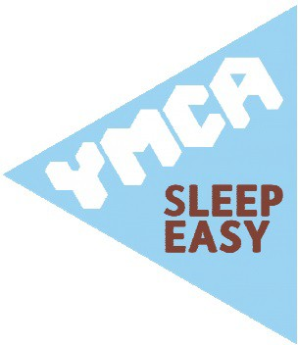
Sleep Easy for YMCA Essex Friday 11 March – Saturday 12 March 2022

1054070

